RUGBY HIGH SCHOOL
CREATIVE WRITING MAGAZINE

Winter 2019

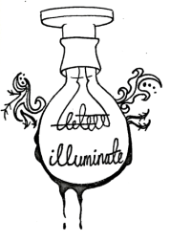
EDITORS FORWARD

Dear Readers,
I am delighted to present you with the latest edition of ‘Illuminate’. You will be able to enjoy the magnificent creativity and talent amongst many of our students here at Rugby High School and I hope that you enjoy reading all of the poetry on offer in this edition.
Within this magazine, each poet takes you on a different journey whether it be emotional, personal, heart-breaking or entertaining and I can assure you you’ll not be disappointed.
In this edition, many of the poems were inspired by the ‘Young Writers Competition’, a national competition. We were given the theme of ‘truth’ as a prompt and this allowed many of our school community to inspire us to write powerful poetry; some of the poems are now published and can be read by all!
Within my final year here at Rugby High School, and as part of the editorial committee, I have seen an abundance of talent and skill within English and the Arts, across all year groups. Therefore, I am pleased with our final publication and know it is worth a read!
Many thanks to the hard work of all the students who have their work featured in this edition, the ‘Illuminate’ Editorial Committee and Mrs Gregory.
I hope you enjoy!
Aaliah Aziz
Year 13
Co-Editor of the Illuminate Magazine
Co-Editors: Lauren Marks, Shona Whelan, Roheena Buckland and Mrs Gregory
“Poetry lifts the veil from the hidden beauty of the world, and makes familiar objects be as if they were not familiar.” – Percy Bysshe Shelley
“The truth is rarely pure and never simple” – Oscar Wilde

CONTENTS

A Tribute to Ophelia Clarke: ‘Gossamer’ – Ruby Murphy, Year 12 4
The Paper Doll – Mya Nicolson, Year 10 5
Captured – India Edwards, Year 10 6
Truth – Harriet Panther, Year 11 7
Our dearly departed – Carys Owen, Year 13 8
Truth – Pippa Thompson, Year 7 9
The Truth, Potatoes have feelings – Simar Randhawa Year 10 10
2020 Vision - Holly Weston, Year 12 11
The Betrayal – Holly Preece, Year 13 12
Amazon – Lexy Beaumont, Year 9 13
To my granddaughter – Ella McCauley, Year 11 14
The Truth About Oranges – Emily Beaver, Year 10 15
The Octopus – Holly Weston, Year 12 16
Poetry in Translation – French Literature Club 18
Accent/ L’Accent 19
The Black-Tongued River/La rivière à la langue noir – Rose Ridley/ Roheena Buckland 21
The Truth/La Vérité – Chloe Barratt-Leafe/ Lola Zukhurova 22

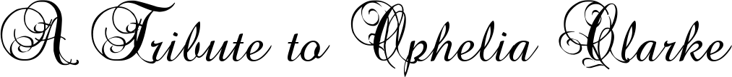
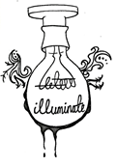

Gossamer

Gossamer
Your toes dip the surface
of that beige summer sun;
two legs of tan
over fifteen denier thin skin.

Family heirlooms
you've inherited
in a cardboard box,

but when someone's gone,
it's these little things that make you smile:

your fists forming puppets in floaty feet,
the gauzy seam a tiny mouth
nipping jokes out of nylon.

but now you're gone,
it's still these little things.

Lingering, limp silk
leaking light
and ladders in my life.
Gossamer ghost,
glowing gauzy

Grecian Goddess,

Stitched in my side.

Hemmed in my heart.

By Ruby Murphy
Year 12

The Paper Doll
Everything is white.
Egg shell walls
encase me
And I have not the strength
to free myself.

If I turn my head a little
and look to the mirror
I see a paper doll
who stares at me with
Valant eyes.
She is pale
and fades into the background
more and more
each day.

So I lie

and wait
Though I do not know what for.

but after
The People come.
they flood in, they surround me
They hate me.
as they take my hands in theirs
Mya Nicolson
Age 15

and feel the chill.
And taste the near-presence
Of Death.
Captured

I capture a moment that is gone forever,
I capture a moment that’s impossible to reproduce.
I capture the colours, the memory, the essence,
I capture a split second for you to use.

for some reason I am a sketch book,
an instrument of and spontaneity.
for others I am a violation,
A silent gun shooting the unprepared reality.

When words are inadequate,
I shall be content with silence.
The subtle art of a photograph,
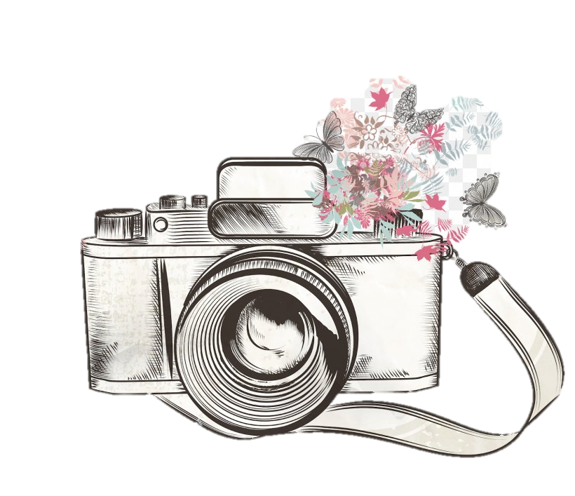
captures love, hate and violence.

India Edwards
Age 14

Truth

What you see is not what I do,
Our lives built on different lies,
different truths
Our perspectives change
spiralling around what we see as good,
Or as bad.
A curse for you is a blessing for me
A cry for help like a victory cheer
Little white lies turn dark
Danger
Yet here we are together.

Harriet Panther
Age 15

Our dearly departed
Passed is for the pretty deaths,
The ones that they remember
But forget
The sick and the swearing
The sobs that wake you up
And the dust that clearing away a lifetime throws up.

And the photo they see at Mass is
Still, a paragon of virtue
Caught in a second
And eternalised forever,
For the sickly shine of paper
Sweeps his faults under the rug
As if they were never there at all.

And that’s what they remember,
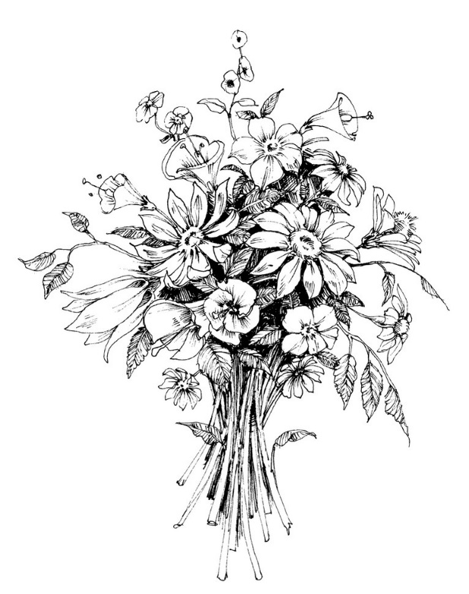
Hovering like a cloud of doom,
Peering at a hole in the ground.
No rains will come of it.
There may be a small shower
But shallow enough it’ll all be
Washed away by morning.

Carys Owen Age 17

Truth

Truth is a slip of someone’s tongue,
A well thought out excuse to lie,
Truth is giving in itself,
Among the embers beginning to die,
Changes as the story grows,
Bent gently as hot iron,
But when the truth is snapped in half,
It is obvious that you’re lying,
Starts off big but ends up small,
Every time you hath repeat,
As you think up wild excuses,
Wily truth becomes deceit,
For no man, infant or teen
Can awaken from this horrible dream,
Opened eyes but still no reality,
Truth and lie have much similarity,
Starting now to believe myself,
The story that has begun to melt,
Even if nobody knows but you,
The lie to the world is the truth to you.

Pippa Thompson
Age 11

The Truth, Potatoes have feelings
I stand in the long line.
My hands glued together. Muttering my final words,
Until it’s time to face my true destiny.

I stand next in line,
Watching my fellows being skinned alive.
Nowhere to turn back to now.

I feel a sharp blade scraping at my skin,
I feel each incision chopping off my every limb.
I bite down on my tongue to hold in the pain,
But screams still manage to escape.

Most have passed out by now,
Or worse,
Died.
However I lay, eyes wide awake.
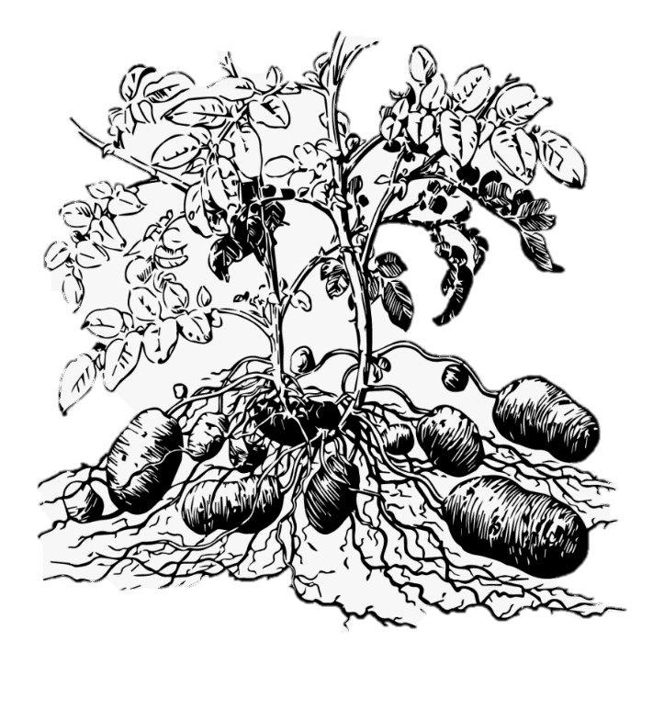
Now I see the pot boil,
Water thrashing violently inside,
My time will soon be up,
But the truth is now out.

Simar Randhawa
Age 15

2020 Vision

The year is 2020 and I have just woken up.
Lenses clicking into place, focusing and clarifying:
The world is huge – green and verdant;
The sky is a boundless blue -
Birds flit about in the air, trilling the songs of their souls,
And the sun shines.
It is warm, and content.

The year is 2021 when I wake up and not all is what it seems.
Trudging down the lane, I see the plastic that frames my vision -
Bottles and bags and cans are pinguid in the fading sun,
Crackling with the beginnings of smog -
A smog of suffocating smoke and sulfur.
It’s encrusted into the nailbeds of the pavement.

The year is 2023 and the light is a dull lustre -
Through a smokescreen of grit and grime -
Signs to ‘BUY NOW!’
Are hollow in their promises, offering only heartless and generic material comforts.
What was once people now shuffle past in a sluggish and hazy stream.
The monotony of life has dulled their actions -
To the limited range of small phone screens.

The year is 2025, and the sun is oppressively hot.
Systems overheating...
The air-conditioning offers a breathless sigh.
Electricity has long since departed, along with the Earth’s own fuels,
Its’ gems and minerals.
An empty husk of what once was.
Life has deteriorated, culture as a distant memory.

The year is... 2027.
There are... regrets.
A snarling, savage storm slices through half the remaining contenders.
They begin to question: why didn’t they act sooner?
They entrust history to the hard, silicon hand of the machines.
We are the future, they tell us, but we know -
Deep down, inside our artificial hearts – that that isnt true.

The year is 2028, and I am just shutting down.
Lenses clicking into place, cracked and failing.
The world is small – a withered shell of humanity;
The cities crumble to dust around us –
The wind howls its silent misery.
The sun is dead.
And we wish, yet again, that we had the clarity of 2020 vision.

The Betrayal

Vocabulary changed from love to repulsed,
Unusually untruthful,
A loss of respect,
Abandoned, naïve, broken.

The building blocks of our relationship
destroyed.
A feeling worse than heartbreak, the choice of her
over us.

We were easy to discard,
you’re the new picture perfect family,
Happy, complete,
You left us, you betrayed us,
Easy for you to find and create a new family,
Harder for us to replace a father.

Holly Preece
Age 18

Amazon
Look!
A human.
Funny creatures.
It walks by peacefully, admiring every inch of the forest,
padding across the lush blanket of foliage.
We, however,
stand like soldiers lining the horizon,
arms stretched up towards the sky.
Watching. Observing.
Thousands of us, waiting.

Pieces of jade and emerald shoot up from the ground,
the gentle harmonics of birds float in the air.
We feel cosy even in this vast space.
Look!
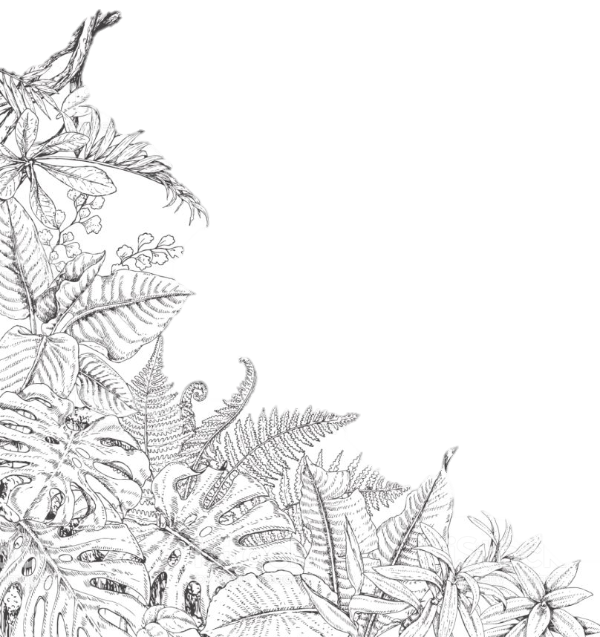
A human!
What’s it doing?

Before we know it smoke plumes bloom across the sky.
What was once clear and open is now dark and clouded.
Tongues of fire lick the base of bushes.
Like snakes writhing, they slither up a trunk.
Ribbons of light burst up before me, illuminating the area
whilst embers leap and dance.
But why? When will it end?
Fire hungrily devours everything I know,
a world once full of life now contains only rubble
and charred greenery

as ash falls around me.

Lexy Beaumont
Year 9
To my granddaughter

As I picture all the joy and wonder,
I remember the crash of ravishing thunder,
the ticking bomb beating in my chest,
the solemn ability to only rest.

Whilst seeing my family flourish and grow,
I can’t help but to let the tears flow,
the fact there is no hope or cure,
makes me think my illness is premature.

The bond between my granddaughter and I,
no matter what, will never die –
even if my heart’s no good,
with an inability to pump my blood.

Ella McCauley
Year 11

The Truth about Oranges

Butterflies rise from the orange tree in clusters,
they’re lazy in the way they float,
wings sticky with the remnants of golden juice,
carrying that sickly stench
through the air.
Orange is not the colour of ripe fruit
hanging from branches,
orange is the magnificent shade of
her hair when the sun hits just right
or the splash of freckles
across her cheekbones,
it is the sky at dusk and the colour of October,
but it is not the colour of oranges.
Orange is the colour
of locked fingers and fleeting glances
of first dates,
not quite red, but not yellow either.
it is the colour of dew sprayed
across thick green skin
pumped full of chlorophyll;
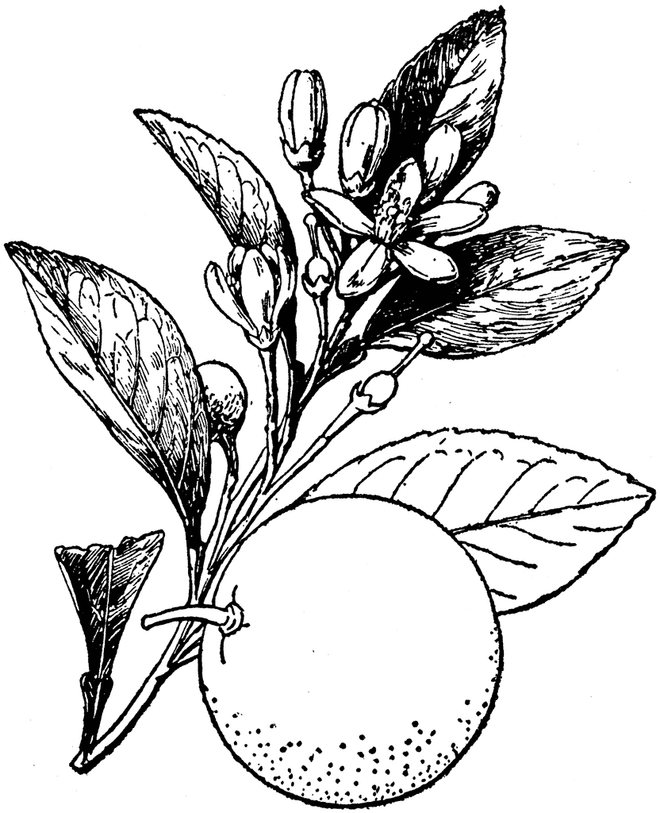
by the time they reach orange however,
they’re dropping from branches
and falling towards rot
soft and sour with fragile, bruised skin.

The truth about oranges is
they’re not always orange.

Emily Beaver

Year 10
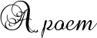

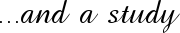

The Octopus

Of hearts, she has three, with viscous blood -
and a mucous-like mantle, octamerously-legged,
limbs dotted with shallow cavities
and adhesive, chitinous cuticle.
Cephalopod curling about crustacean -
a flash of an iridescent beak,
all under the contractions and contortions
of camouflage -
of the cracking of a clam, the withered form of a whelk
of the pigmented locomotion of an eldritch beast,
extending and stretching and squeezing -
shrapnel of sharp shell settling about her,
resplendent remains becoming a crown of thorns -
before she spurts away; a shadow of melanin ink.
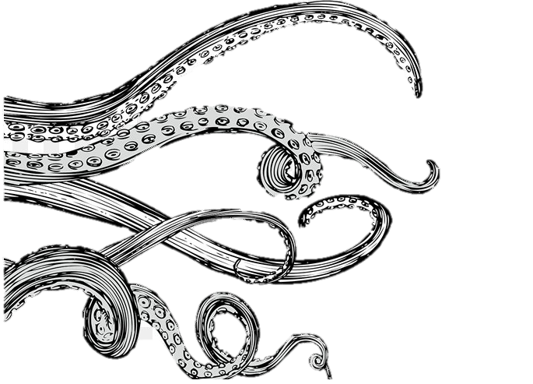
Holly Weston
Year 12

I really liked Isabel Galleymore's poem, 'The Starfish', because I felt that the way she presented the starfish without ever directly mentioning it by name showed how skilled she is in her use of eloquent metaphors and similes (such as 'navy mackintosh' and 'the shopping bag of her stomach') to depict a story solely by 'show' not 'tell'.

I wanted to mirror her poem and its techniques by writing a poem that is similar, with similar techniques, whilst still keeping it unique. I wrote my poem on the theme of an octopus, as I was inspired by 'pentamerously-legged' possibly being able to become 'octamerously-legged'.

I did some research on the nature of octopi, including where they live, what they're scientifically called, (cephalopods), what they eat, (crabs, whelks, molluscs – crustaceans), and the texture and properties of their bodies (mucous-covered, beaks, tentacles with cuticled suckers). I found this research interesting, and not altogether different from the lifestyle of a starfish.

In terms of literary techniques, I wanted to use alliteration to recreate the sound of the cracking of shells as the octopus eats it: 'chitinous cuticle', 'curling about crustacean', 'beak', 'contractions and contortions', 'camouflage', 'cracking of a clam'. I thought this would create an interesting emphasis on the octopus's strength in cracking the shells. I later wanted to use sibilance to soften this affect to be in more of a likeness to the octopus's soft body, and therefore show the contrast between the two.

I hope that by using these techniques, I can create a similar effect as Galleymore's impressive use of language, and invoke a vivid an image of an octopus as she has of a starfish, and the impressions of awe and wonder they leave on readers and listeners.

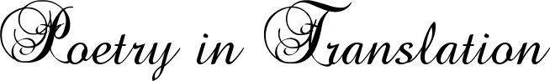

Following are a few poems written by students of RHS, alongside translations done of them by the French Literature Club at school. Translating poetry can help to explore both the meaning of the original poem in depth, and the differences between languages and their structures. It is an incredibly difficult thing to do, especially when idioms and double entendre are used, as choices often have to be made as to whether to translate the meaning or the sounds, or even which meaning when there are multiple interpretations.
The following poems have followed quite a direct translation of the words written, as this is perhaps the most straightforward. We likewise chose poems without a strong rhyme scheme to translate, for that would bring a great deal more complexity where meaning and rhyme don’t align. It is unlikely that any translation will ever be able to confer the sense of the original exactly, but then again, given the subjectivity of the interpretations of poetry, perhaps that is less of an issue than it may originally seem. If there is no hard and fast meaning, shifts in the poetry may be less damaging. It was once said by someone that the looser the translation, the better the result, and that the best translations were those that were good poems by themselves in translation, rather than relying on the originals. This is perhaps the opposite of the approach that has been followed here, but the system we chose has helped to bring some of the problems of translation itself to light for the French Literature Club.

Accent

Disowned, unloved and ashamed of,
Or proudly displayed like a trophy won through years,
I am the foreigner’s pride and tyrant,
I am the pushing and churning of syllables to your ancestors’ beats,
I stick around whether you like it or not,
I am a map to the home of your fathers, your mother, you grandpa and your long-lost great auntie,
I roll off the tongues of each of the 7.7 billion people in this chaos of a world,
I’m the reason you didn’t get that job, but I’m also the reason that your people recognise you as one of their own,
Do you not like me or do they not like me and you don’t like that?
Do you want to hide me in the recesses of your throat or wear me like a badge of honour, like an Olympic medal, like a tiara of diamond?
Am I your crown of thorns, your burden to carry, the reason why you get teased and bullied and pushed?
Or am I just there and you’re okay with that.
At the end of the day I am who you are, and you can’t escape that,
And no matter how you see me I’m going to be here for years to come.

L’Accent
Désavoué, mal-aimé et embarrassant,
Ou fièrement affiché comme un trophée gagné à travers les années,
Je suis et la fierté et le tyran des étrangers,
Je suis la bousculade et le roulement de tes ancêtres,
Je reste n’importe si tu m’aimes
Je suis la route à la maison de ton père, ta mère, ta grand-mère et ta tante du temps perdu,
Je suis la chanson sur les lèvres de chacun des 7,7 milliards de gens dans ce monde chaotique,
Je suis la raison pour laquelle tu n’as pas obtenu cet emploi, mais je suis aussi la raison pour laquelle tes gens te reconnaissent comme l’un de leurs.
Ne m’aimes-tu pas ? Ne m’aiment-ils pas et tu n’aimes pas cela ?
Est-ce que tu veux me cacher dans les recoins de ta gorge ou me porter comme un badge d’honneur, comme une médaille olympique, comme un diadème de diamant ?
Est-ce que je suis ta couronne d'épines, ta charge à supporter, la raison pour laquelle tu te fais moquer et terroriser et pousser ?
Ou est-ce que je suis simplement là et t’es bien avec cela.
Finalement je suis qui tu es, et tu ne peux pas le changer.
Et n’importe comment tu me vois je serai là pour des années à venir.

Black-tongued River

He just fell in, but then again…
I am the black-tongued,
River-rushing, always moving,
Never stopping, flooding reason,
Always flowing and…
Somehow…

No-one wants to be that little stone,
At the bottom of the river that says,
Stop. Enough’s enough.
Whoever you are, whatever you’ve done,
There’s no need for me- yeah, right.

I will stop, I am the river from hell,
River-rushing, always moving,
Never stopping, flooding reason.
Once started I will never cease.
Roaring on, until it’s too late.

Rose Ridley
Age 12

La rivière à la langue noire

Il vient de tomber, mais là encore…
Je suis la rivière à la langue noire,
Déchainée, en perpétuel mouvement,
Sans fin, j’inonde la raison,
Toujours circulant et…
Pourtant…

Personne ne veut être ce petit caillou
Au fond de la rivière qui dit :
Arrêtez. Ça suffit.
Ou que vous soyez, quoi que vous ayez fait,
Il n’y a pas besoin de moi- oui, bof.

Je ne vais jamais arrêter, je suis la rivière infernale,
Déchainée, en perpétuel mouvement,
Sans fin, j’inonde la raison,
Quand j’ai commencé, je n’arrêterai jamais.
Un torrent rugissant, jusqu’à ce soit trop tard.

Roheena Buckland
Age 18
The Truth
Bliss.
That’s what I am.
Quiet as the winter’s night,
Loud as the new-born’s cry.

Bliss.
That’s who I am.
I am what lurks restlessly in the shadow,
And what fills a room.

Bliss.
That’s who we should be.
Be what comes between cities and the countryside,
And what hides behind corners, waiting to be found.

Bliss.
I am how it should be.
I am what holds together night and day,
And what blinds evil without a trace.

Bliss.
I am what your planet needs.
What will prevent hurt,
And what will force truth.

I am the voice of Bliss,
And I am coming.

Chloe Barratt-Leafe
Age 11
La Vérité
La félicité.
Voilà ce que je suis.
Silencieuse comme une nuit d’hiver
Bruyante comme le cri d’un nouveau-né :

La félicité.
Voilà ce que je suis.
Je suis ce qui se cache sans cesse dans l’ombre,
Et ce qui remplit une chambre.

La félicité.
Voilà ce que nous devrions être.
Soyez ce qui vient entre les villes et la campagne,
Et ce qui se cache derrière les coins, attendant d’être trouvé.

La félicité.
Je suis comment cela devrait être.
Je suis ce qui tient ensemble la nuit et le jour,
Et ce qui aveugle le mal sans trace.

La félicité.
Je suis ce dont ta planète a besoin.
Ce qui va prévenir la peine,
Et ce qui va forcer la vérité.

Je suis la voix de la félicité.
Et j’arrive.

Lola Zukhurova
Age 16

