Preparation for A Level French

Bienvenue!

Welcome to RHS and welcome to A Level French. We are really pleased that you have opted to join us for your French AS or A Level and we look forward to working with you.
Please see below for some top tips and ways to prepare for the subject.

Who will be teaching you?
Ms J. Strudwick
Mrs S. Fair

If you would like to contact us before you begin the course, please do so:
j.strudwick@rugbyhighschool.co.uk
s.fair@rugbyhighschool.co.uk

Top tips!

- Join in. It’s OK to make mistakes. Make sure you speak every lesson.

- Try to stick to the target language in class, speaking to your friends in French as well as to the teacher. It’s a great habit to learn.

- Develop your ideas: make sure you have a point of view. Force your family to talk about A Level-style issues at mealtimes (in English!).

- Regular learning of vocab (from “official” lists but also all the words you note down in class)

- Keep up with the grammar. Go home & check you’ve understood. Try some exercises. Ask!

- Organise your folder:

a) Grammar sorted by:
- Verbs
- Nouns, article, adjectives
- Other grammar

b) Topics sorted into the themes (“Bridging the Gap” + the six Year 12 sub-themes)

7) Do something every day to improve your French: reading magazines & blogs, listening to
the news & the radio, watching films, reading a novel.

8) Learn from your mistakes: read through corrected work carefully & follow up on any issues
raised. We spend time marking your work so that you can improve. Please take on board
our advice!

9) Complete your work in advance of the deadlines so that you have time to check it
for accuracy. It is much easier to spot mistakes when you see your work with fresh eyes!

How much work will you have?

Each lesson will generate some homework. Some work will take longer than other pieces but you will need to put in roughly the same number of hours at home as you have timetabled in school. French is learnt best when you do at least a little every day.
Corrected essays need to be re-written (& submitted for re-marking with the original). This will mean you have a perfect version to revise from.

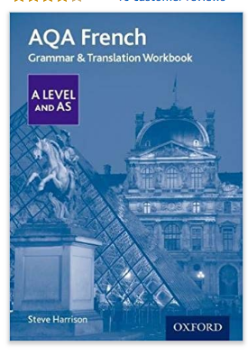
What resources do you need now?

Buy AQA French Grammar and Translation Workbook
by Steve Harrison
Price £10.50
ISBN – 9780198415534
Published by Oxford University Press 2017

Put Collins, WordReference, Reverso and Linguee into your Favourites and download the apps to your phone.

Download the app for Le Monde newspaper to your phone and keep up to date with French current affairs.







