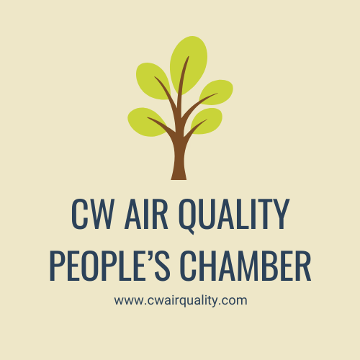

Air Quality / Climate Change School Competition

This competition has been developed by the Centre for Factories of the Future (C4FF) and the Institution of Mechanical Engineers – Midland Region (IMechE). It forms part of the IMechE 175th anniversary year celebrations.

Rules and Conditions
- The competition is open to all secondary school pupils. Whilst it is intended for Midland Region schools, it is open to all schools within the UK.
- Pupils should study the accompanying paper plus any other research material they consider useful and then answer all questions within the quiz. They must also complete an essay / report as described in section 2. This must be around 500 words (+/- 10%).
- The student entry should be supported by a school teacher / mentor / advocate.
- A student may only submit one entry.
- All entries must be submitted by the closing date of 27th January 2022. This is the anniversary date of the founding of the IMechE. Any entries received after this date will not be accepted.
- Entries must be submitted by e-mail to Prof. Reza Ziarati at reza.ziarati@c4ff.co.uk and Mr John Butler at john.butler@imeche.org
- The decision of the judging panel will be final and no correspondence will be entered into.
- There will be 3 prizes awarded to the best entries as judged by the panel. Each winning student will receive a cash prize of £250 plus a framed certificate. Each school of the winning students will also receive a cash prize of £250. Preferably this should be used for a school STEM activity to the benefit of a number of students.

Student name: ……………………………………………………………………. Age: ……………………..

Contact e-mail: …………………………………………………………………….. Tel*: ………………………………….

School: …………………………………………………………………………………………… Class: …………………………………….

School address: …………………………………………………………………………………………………………………………………

School teacher / mentor / advocate: ……………………………………………………………………………………………………

Contact e-mail: …………………………………………………………………….. Tel*: ………………………………….

* - Optional
Section 1 - Quiz

Use the supplied report and any other research information to answer the following questions.
When giving your answer make reference to where in the report you obtained your information. If other documentation / reference material is used, it would be useful to give a reference to the source. Further detail concerning your answer can be included in the “Reference” section.
- The stratosphere is the one of the Earth’s blankets.
TRUE
FALSE

Reference:

- The GHGs are mainly a product of human activity and not found in significant amount in nature.

TRUE
FALSE

Reference:

- One of the UNEP’s main purposes is to encourage the co-ordination between countries in order to be a unified response to the climate changes.

TRUE
FALSE

Reference:

- The Kyoto Protocol is concerned with the reduction of the emissions for all kinds of transportation specifically in marine and aviation sectors.

TRUE
FALSE

Reference:

- Climate change is a common concern of human kind requiring a global response.

TRUE
FALSE

Reference:
- According to IPCC, carbon dioxide (CO₂) gas has the most influence on global warming.

TRUE
FALSE

Reference:

- Main sources of human-related CO₂ emissions is due to:
- Burning fossil fuels
- Deforestation
- Transportation
- Industrial and household uses

Reference:

- What is the major cause of the CO₂ production?
- Natural causes
b. Human activity
c. Natural causes and human activity
d. Sun’s radiation

Reference:

9. What does the troposphere not contain? Hint: you need to do some research.

- Ozone
- Refrigerants
- Fluorocarbons
- All of above

Reference:

10. When approximately did the production of CO2, N2O and CH4 start to increase exponentially (increasing by substantial amount)? Hint: See Figure 8

a. The1600s
b. The 1700s
c. The 1800s
d. The 1900s

Reference:

11. What country is the main polluter on a global scale?

a. China
b. Russia
c. USA
d. Germany

Reference:

12. Fill in the Blanks – Hint: the size of blanks does not necessary represent the length of the answer

- Without the ……………..... the Earth would be too cold for life to be sustained.

Reference:

- A not well known impact of the CO₂ pollution is the ……………....... of the oceans.

Reference:

- The combined efforts of UNEP and the ………………. created ………………….

Reference:

- The Doha Amendment in the Kyoto Protocol, states that in the second commitment period the participant countries have committed to further reduce the GHG emissions by …………. at minimum compared with the levels in the 90s.

Reference:

Section 2 - Assignment essay / report
Describe how you / your family can make changes to your lifestyle and/or other actions which will result in the reduction of GHG emissions. (500 words +/- 10%)

